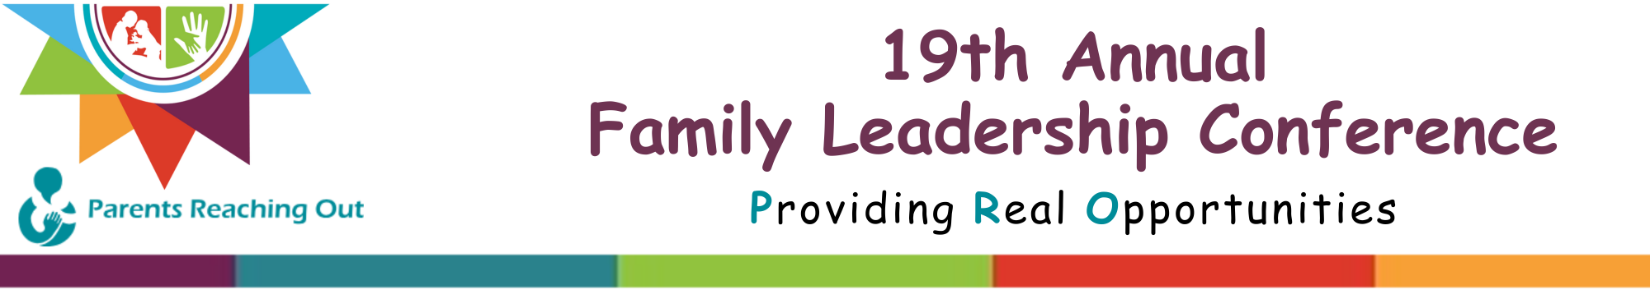

Sponsorship Opportunities
Conference Partner
• Full-page advertisement in the event program.
• Inclusion on event promotional pieces (mailings, emails, and flyers).
$10,000 +
• Company name mentioned at the conference opening and at the general session.
• One complimentary exhibit booth at the Conference in the highest-traffic location.
• Signage on the Parents Reaching Out conference web page with your logo and link.
• Social Media Recognition • Five adult registrations to attend the conference, including all meals and materials.
• Option to include marketing materials in conference attendee’s registration bags. (pens, keychains, fidget toys, etc.)
Conference Advocate
• Half-page advertisement in the event program.
• Company name mentioned at the conference opening and at the general session.
$5,000

• One complimentary exhibit booth at the conference.
• Signage on the Parents Reaching Out conference webpage with your logo.
• Social Media Recognition
• Registration for three adults to attend the conference, including meals and materials.
• Option to include marketing materials in conference attendee’s registration bags . (pens, keychains, fidget toys, etc.)
Conference Supporter
• Business-size card advertisement in the event program.
$3,000
• Company name mentioned at the conference opening and at the general session.
• One complimentary exhibit booth
• Signage on the Parents Reaching Out conference webpage with your logo.
• Social Media Recognition • Registration for three adults to attend the conference, including meals and materials.
Conference Believer
• Business-size card advertisement in the event program.
$1,000
• Company name mentioned at the conference opening and the general session.
• One complimentary exhibit booth
• Signage on the Parents Reaching Out conference webpage with your logo.

